# Creating a PostProcessing Custom Shader

* https://www.youtube.com/watch?v=mzydOmgN7mc

1. Change Material Domain to PostProcessing

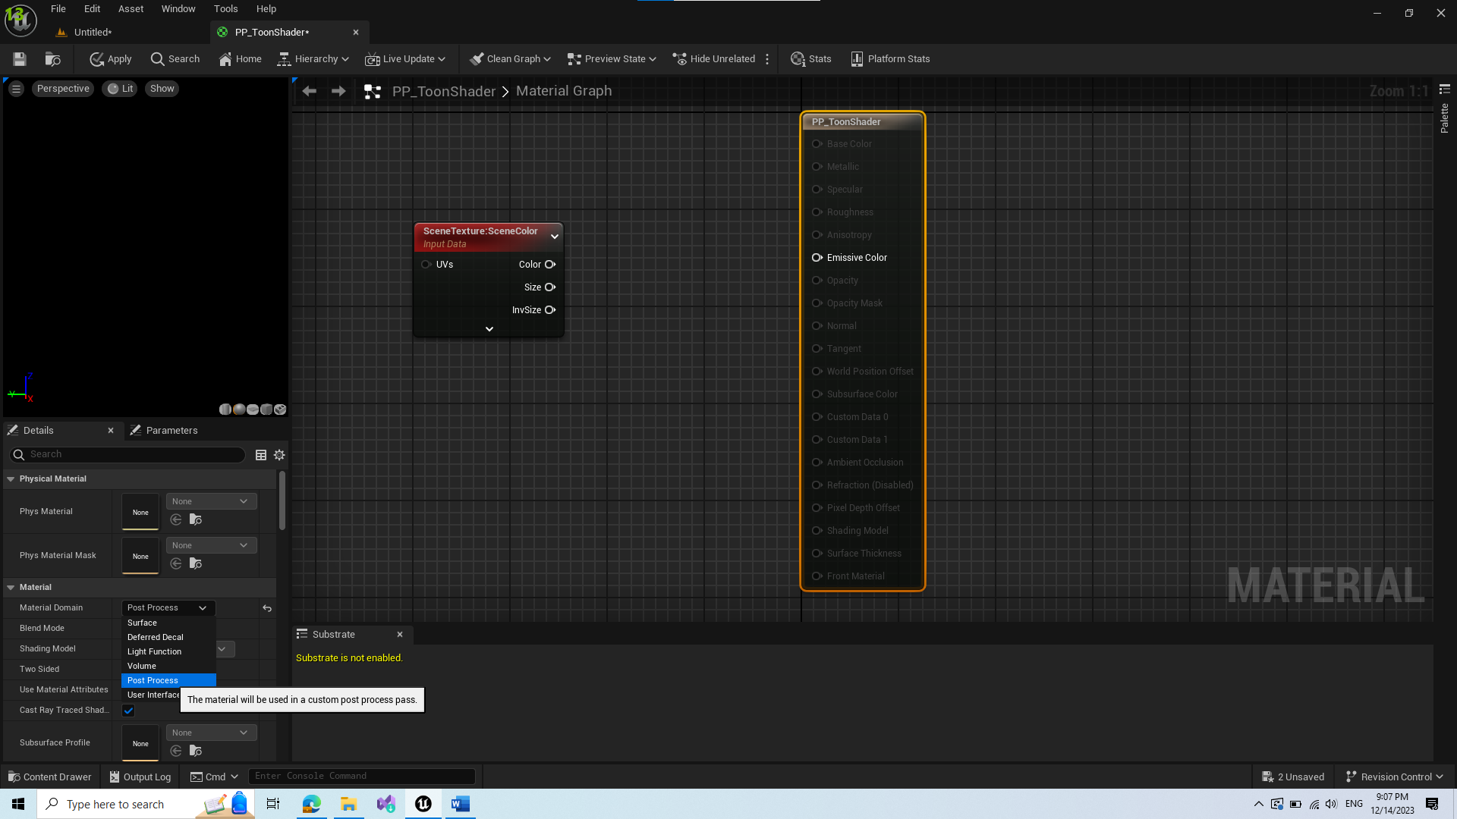

1. Add SceneTexture Node and change Id to PostProcessInput0

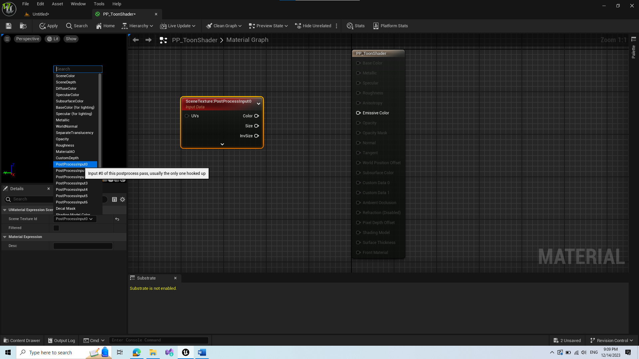

1. Add Desaturation – creates grayscale filter

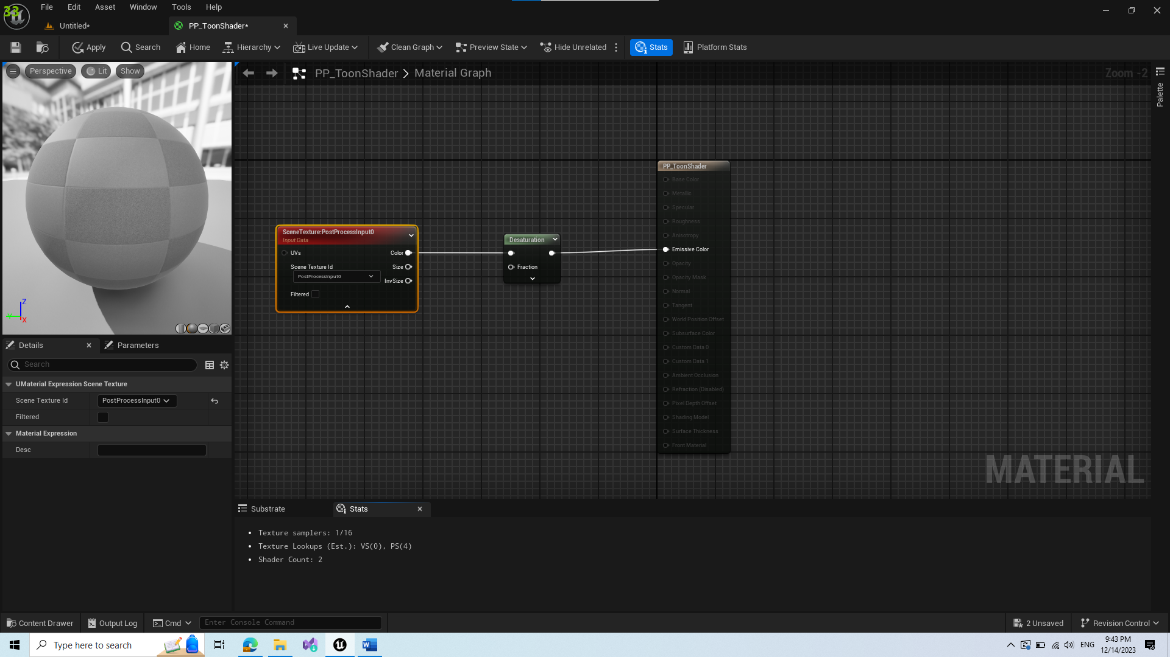

1. Change Blendable Location from After Tonemapping to Before Tonemapping

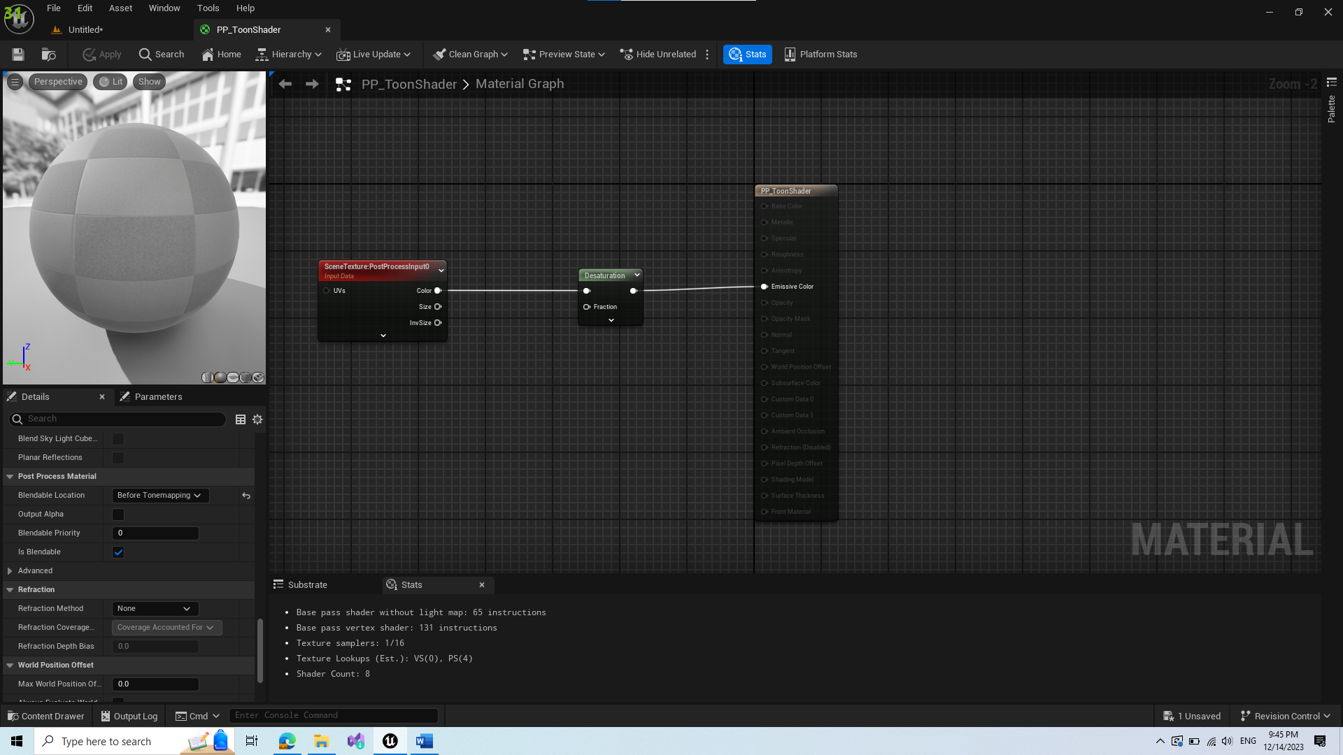

1. Save and create Material Instance from this
2. Create PostProcess Volume and add Material Instance to its rendering features (can check infinite bound to apply outside of bounding box)

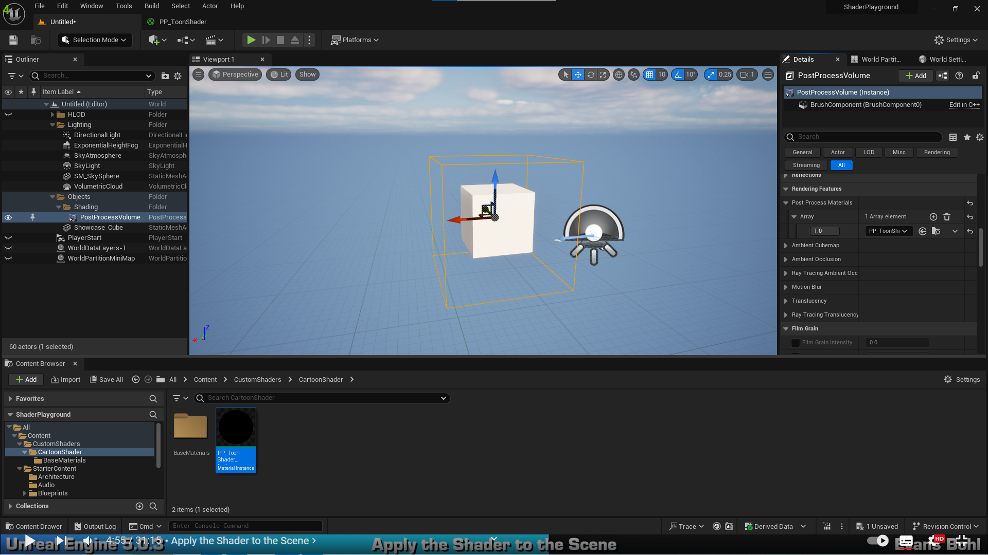

I believe this was just an introduction until this point.

1. Create a new SceneTexture and set its Scene Texture Id as BaseColor(stored in GBuffer)

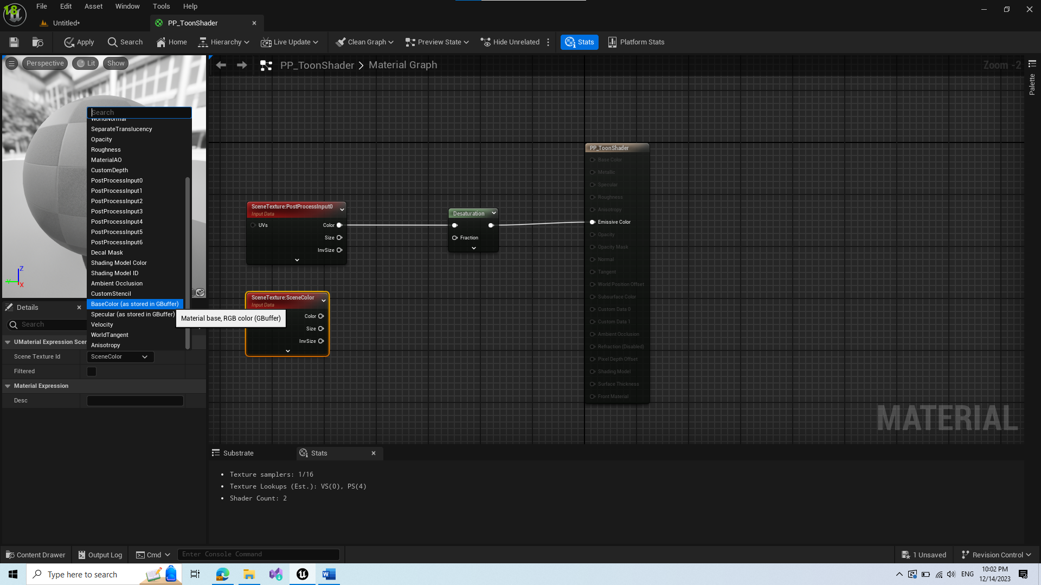

This will result in ignoring lighting buffer and will have basic colors of materials. Next we copy the desaturation and connect it to new SceneTexture.

1. Divide the upper texture with lower

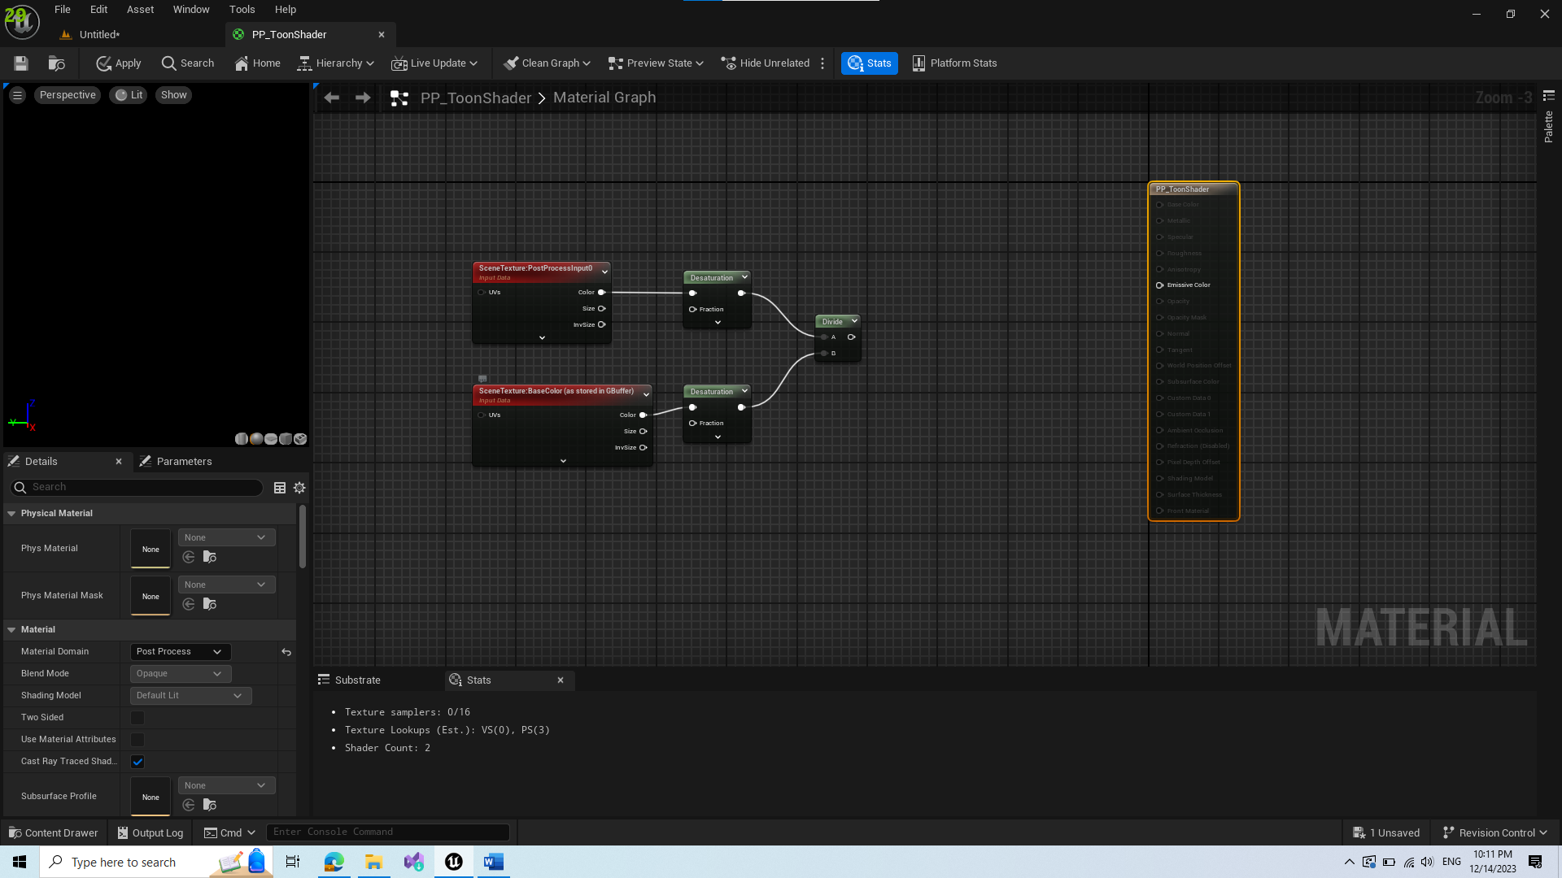

1. Add Saturate Node

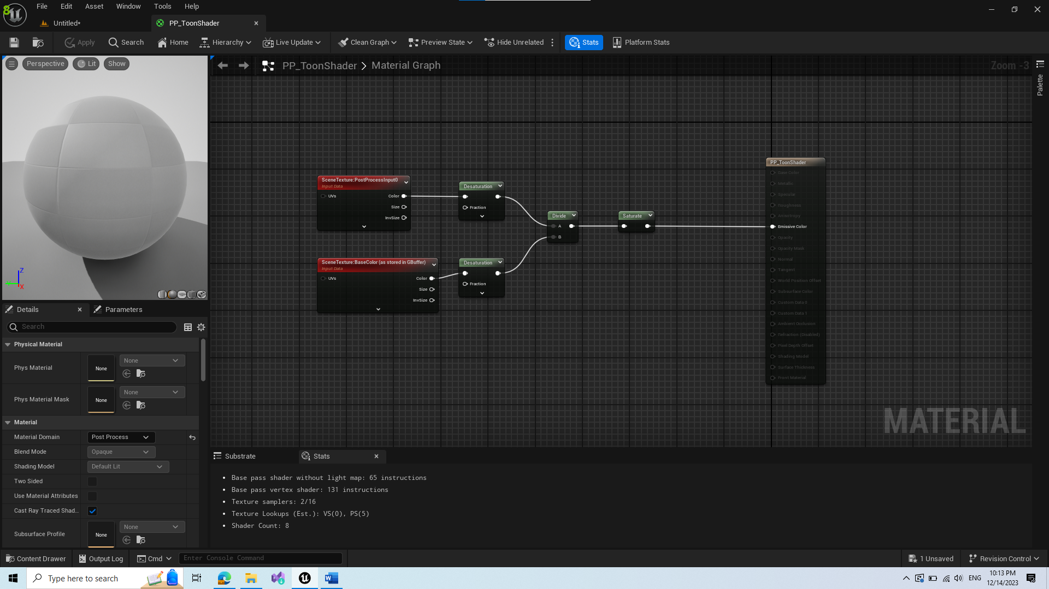

1. Add Mask and select only 1 channel(they are all the same)

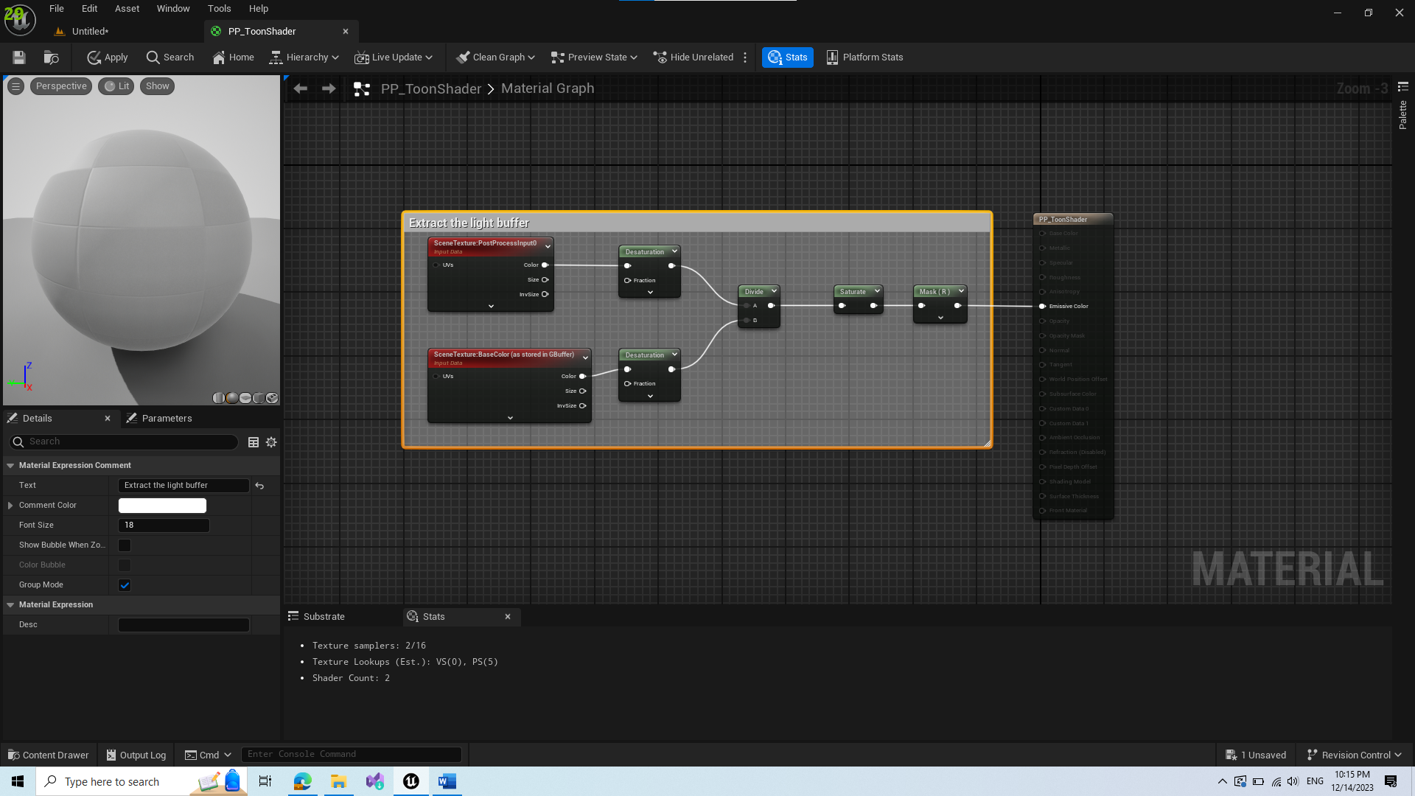

Result should be extracted light buffer, and visuals should be grayscale, 0 where there is no light, 1 where light is directly hitting the surface.

1. To have a strong transition between black and white, we add step with param 0.5. If a value for a pixel is <0.5 then it changes into 0 and becomes black, else its white. However this transition is not smooth and needs improvements.

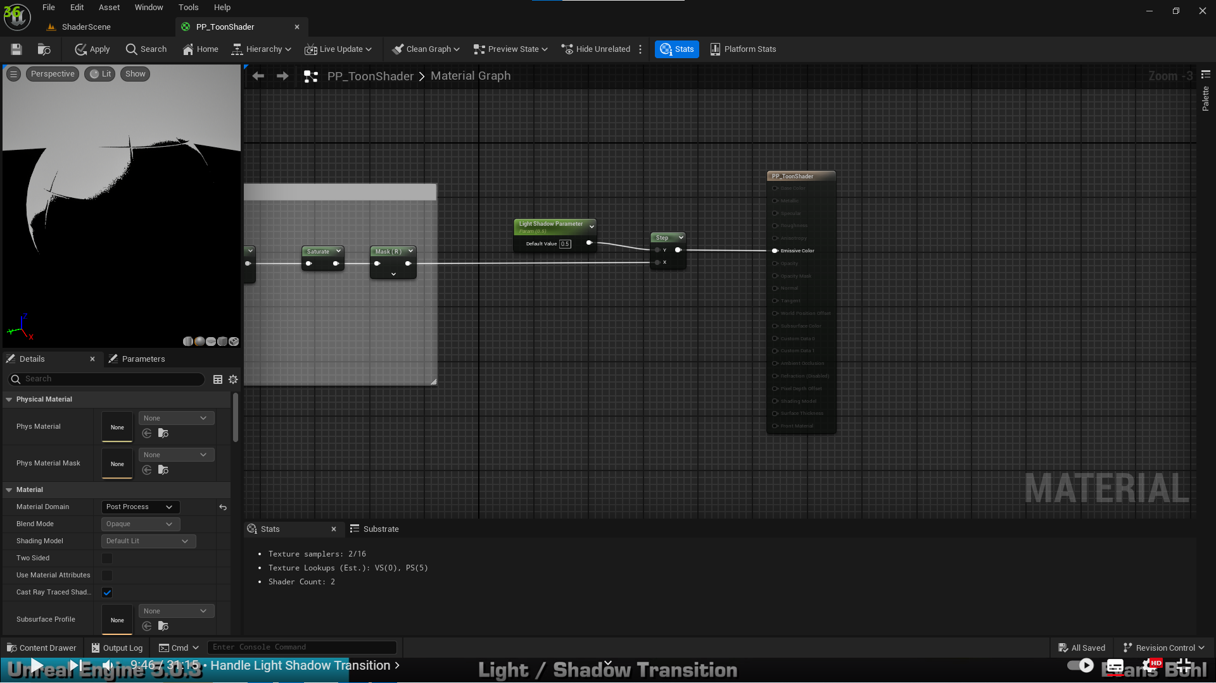

1. Creating a transition

Heres a simple drawn explanation:

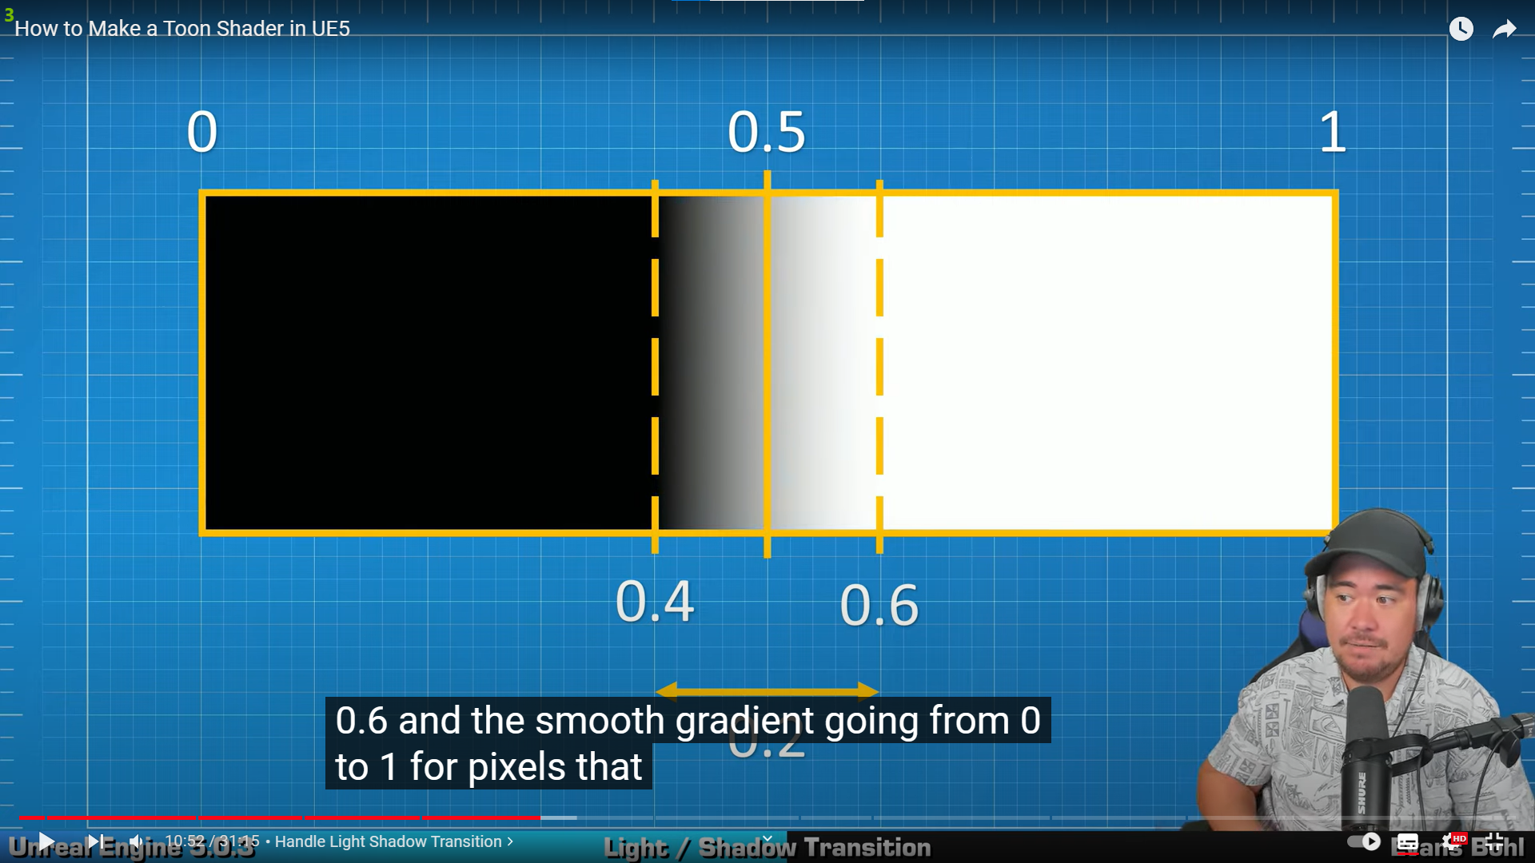

We introduce smooth step between 0.4-0.6 as represented in sketch:  
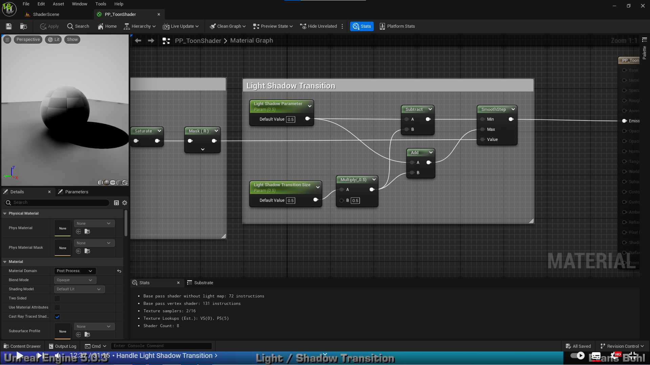

1. Adjusting colors so its not black or white but our own custom colors

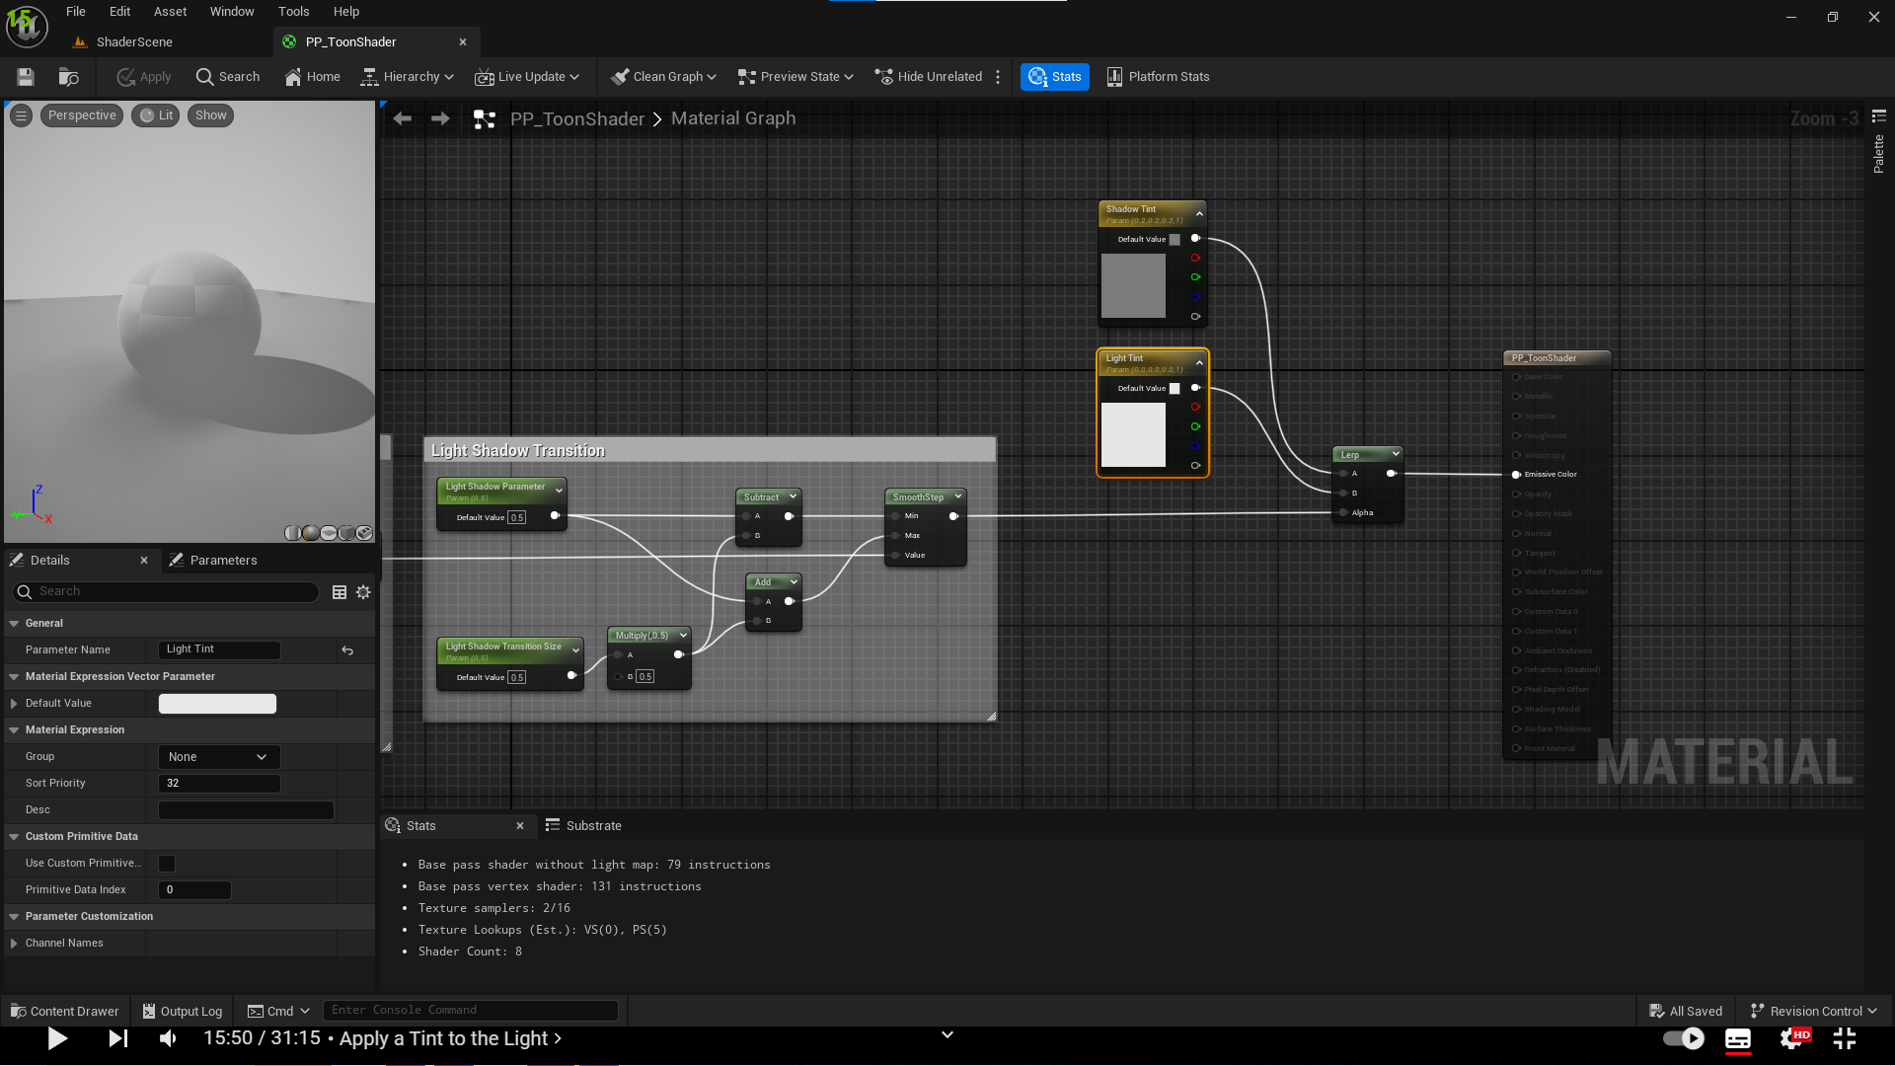

We can adjust these colors in our material instance.

1. Applying lighting with color will not change the color. For that we introduce blending between its color and tinting parameters we introduced earlier.

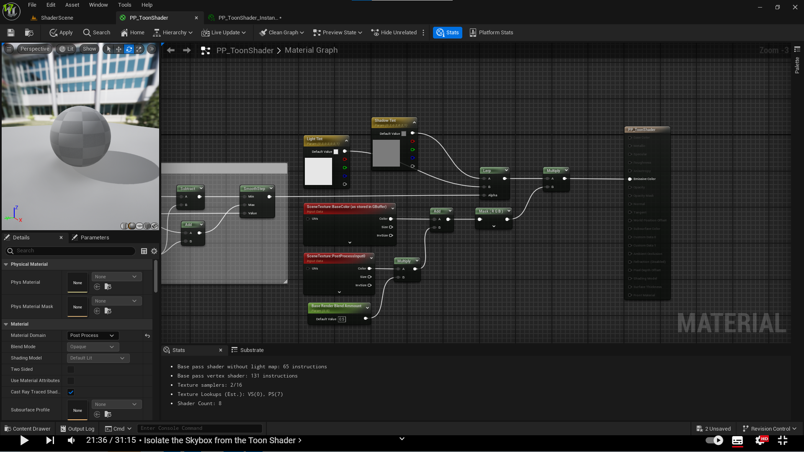

1. Define max distance for applying this effect, this way skybox for example unchanged

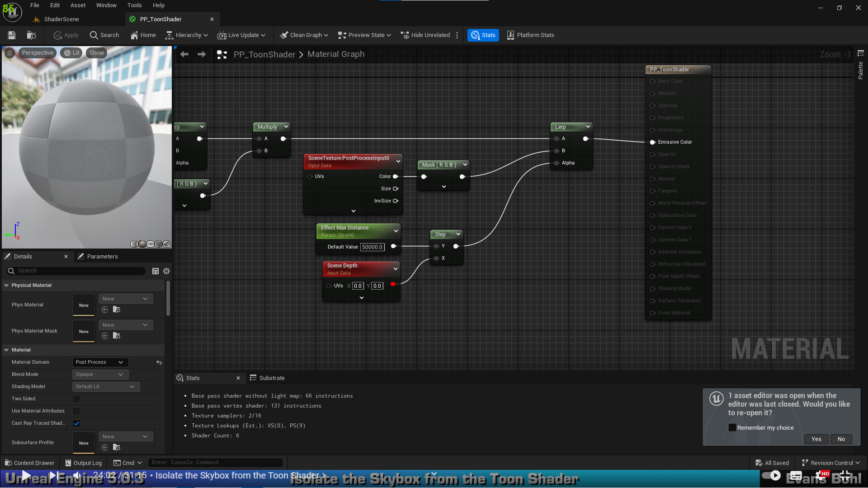

1. To apply effect to only some objects, we need to select the objects with Render CustomDepth Pass Boolean

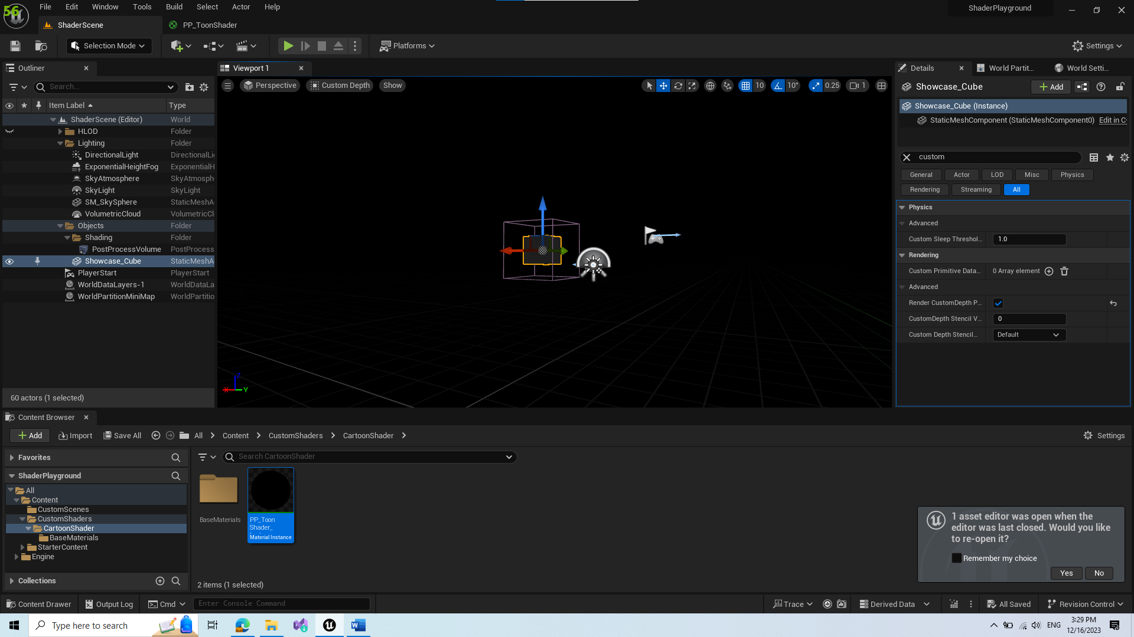

After that we need to adjust our effect to filter only selected objects

1. Now we get custom depth objects in this effect, however this results in wall hack possibilities

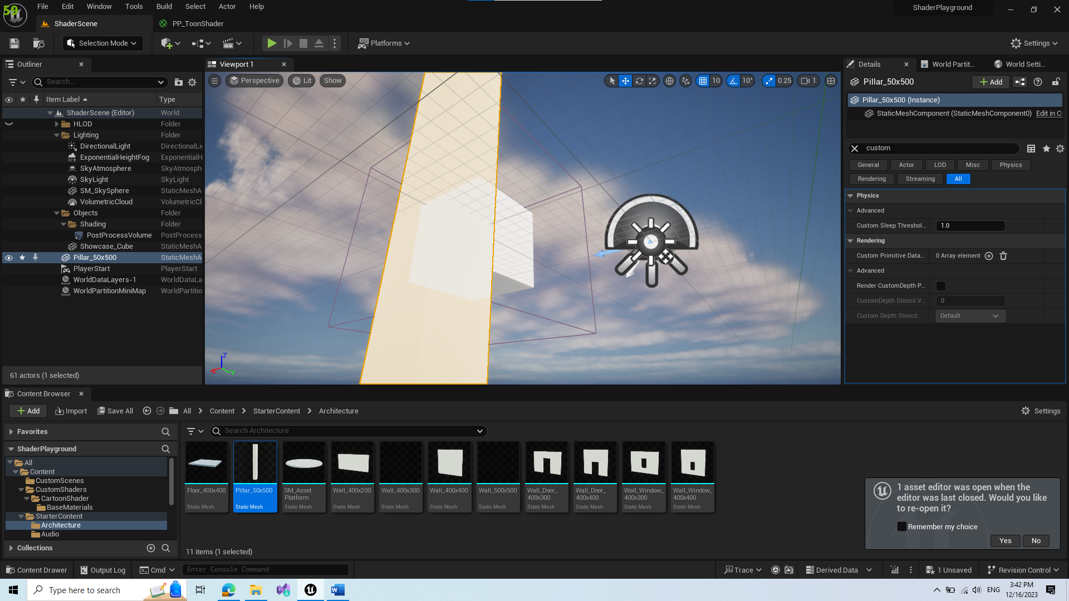

To solve this we need to adjust the effect so it checks sceneDepth if our custom depth object is 1st in camera

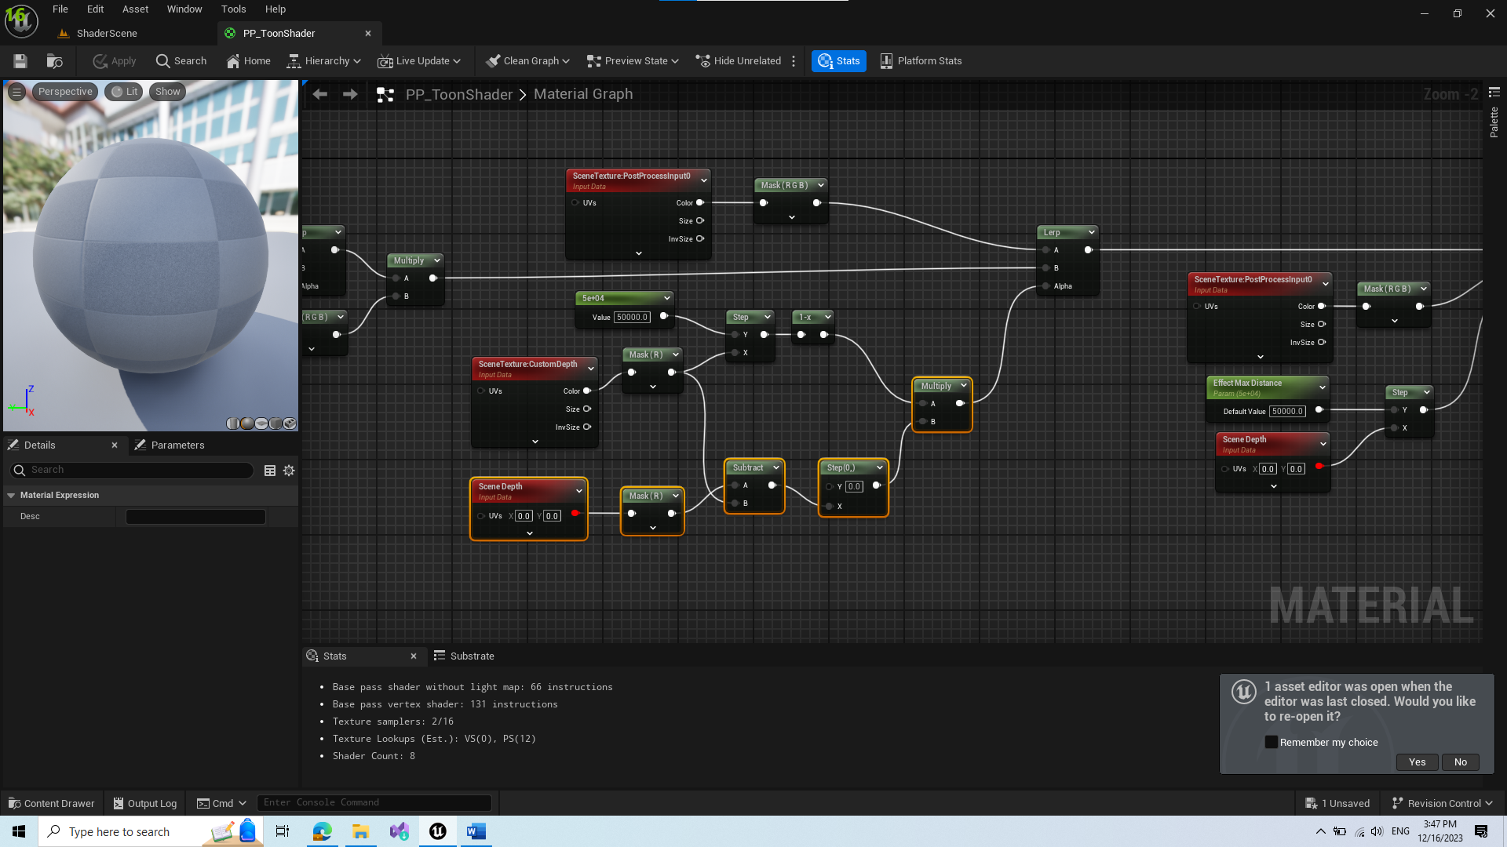

1. Create an option for enabling and disabling this

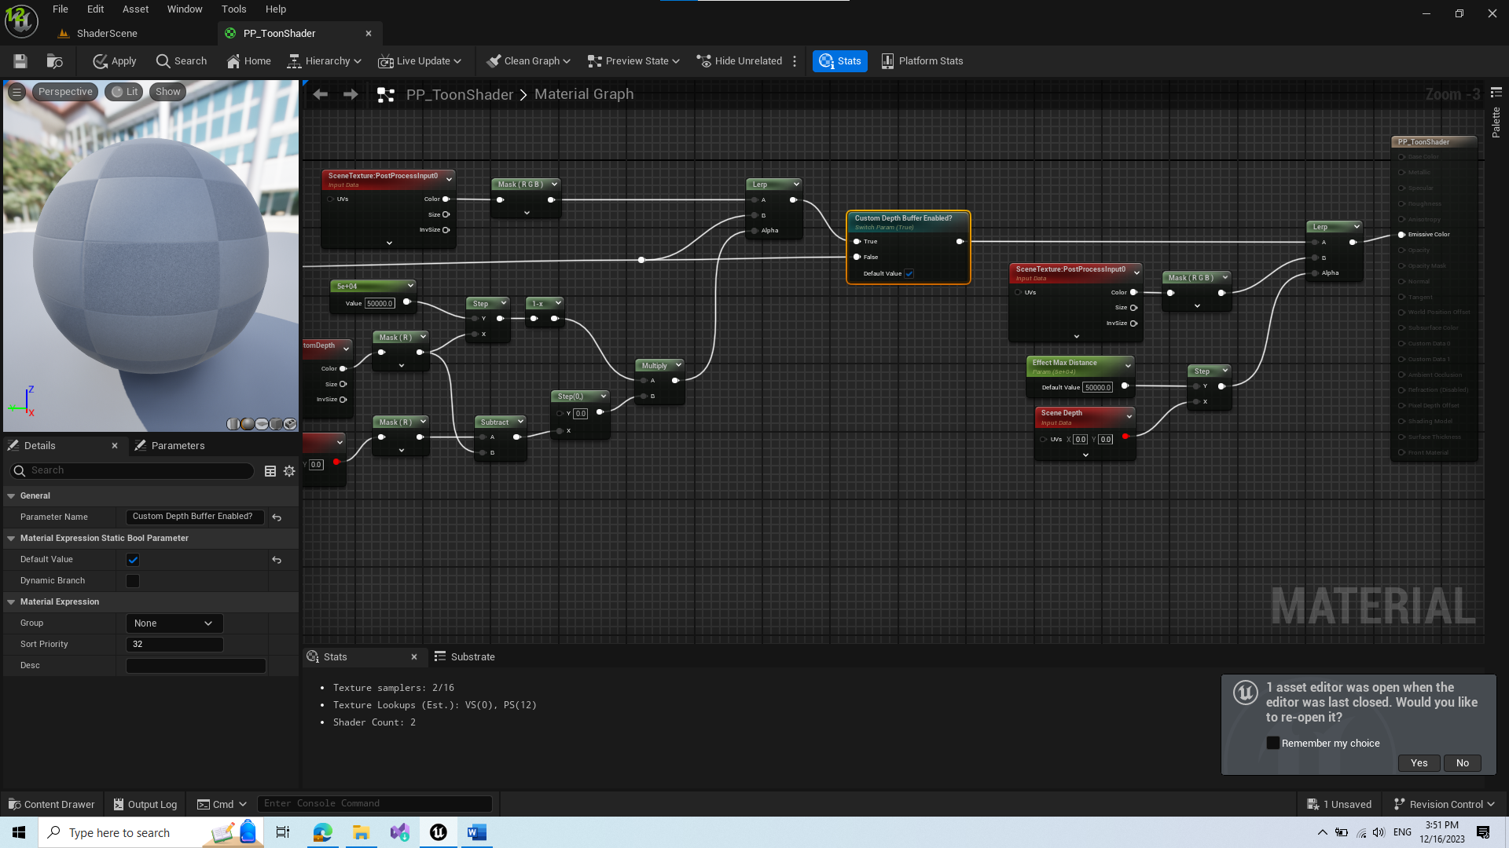

1. Create option to enabling custom depth wallhack

